**CCL Assignment No. 4**

**Name**- Rohit Anirudha Pendse

**Roll No.- 33358**

**Batch- N11**

**Contact No.- 8766925932**

**Email Id-** [rapendse2002@gmail.com](mailto:rapendse2002@gmail.com)

**ID card-**



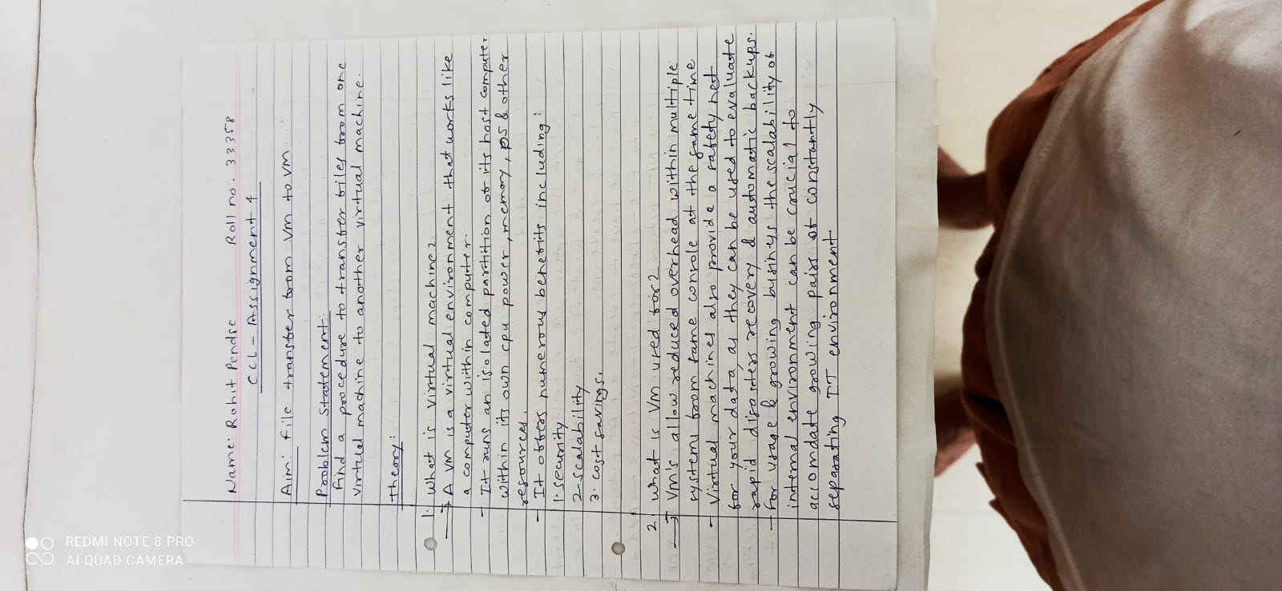

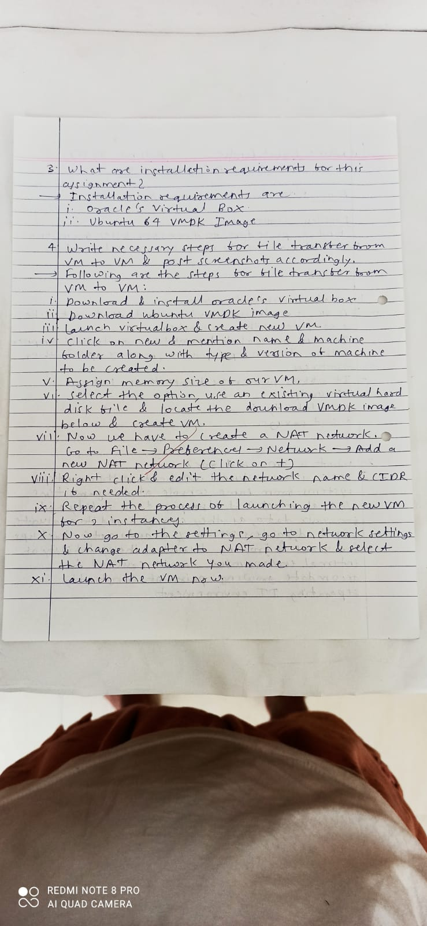

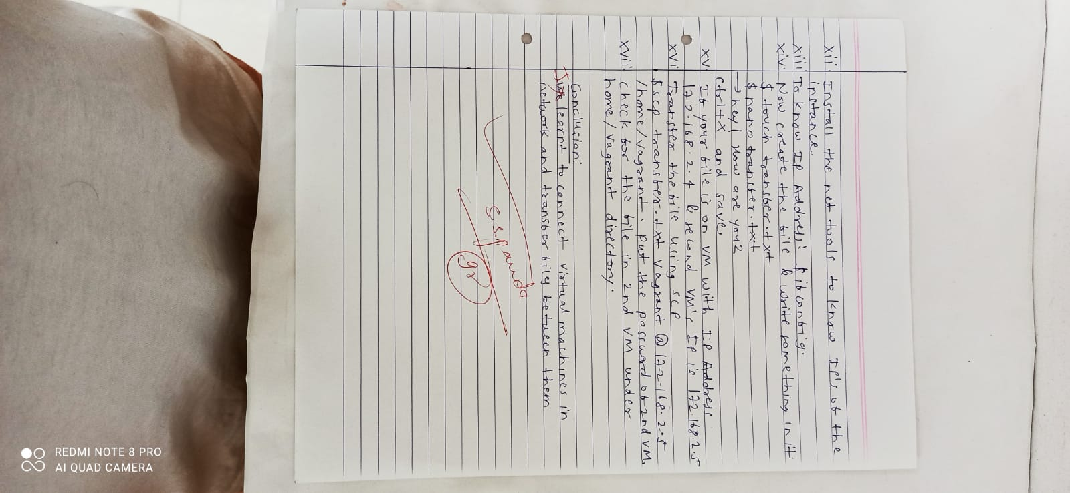

**Code and Output screenshots:**

